**Calendar GUI using python**

## ****Project Prerequisites:****

* We are only using 2 modules in our project those are the calendar module which is the main module of our project and the Tkinter module for the GUI of our project.
* The calendar module allows you to output the calendars. Before moving to the coding session, we must know what methods we’ll be using for the calendar.
* To know more about the calendar module refer to this link – <https://docs.python.org/3/library/calendar.html>
* We will also be using the Tkinter module along with the calendar to display the calendar in GUI.

## ****Getting Started:****

* As we are using the built-in modules, we don’t have to install any modules.
* First, we’ll start by creating a directory with the name of the project – **“Calculator_GUI”.**

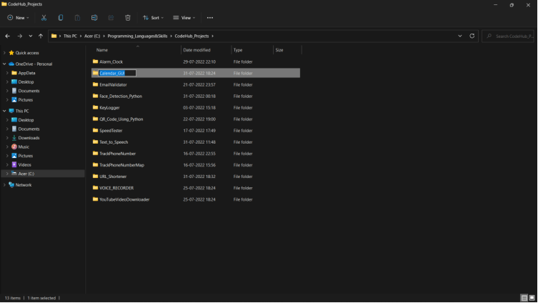

After that, we’ll create a file named – **“calendarGUI.py”.**

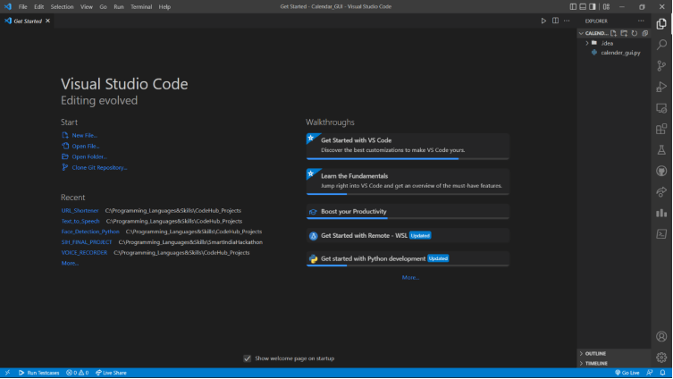

Now that we have completed our setup for the project let’s move to the coding section.

## ****Code Implementation:****

You must have good knowledge of the Tkinter module to understand the code better.

We’ll start the implementation by importing the required modules as always.

|  |  |
| --- | --- |
| **1**  **2**  **3**  **4** | **#Importing tkinter module**  **from tkinter import \***  **#importing calendar module**  **import calendar** |

After that, I’ll be defining a function named – **“showCalendar”**. In this function, we make the GUI for the Calendar and also put the information into the GUI. We run this in a loop so that the GUI stays on the screen.

|  |  |
| --- | --- |
| **1**  **2**  **3**  **4**  **5**  **6**  **7**  **8**  **9**  **10** | **def showCalender():**  **gui = Tk()**  **gui.config(background='grey')**  **gui.title("Calender for the year")**  **gui.geometry("550x600")**  **year = int(year_field.get())**  **gui_content= calendar.calendar(year)**  **calYear = Label(gui, text= gui_content, font= "Consolas 10 bold")**  **calYear.grid(row=5, column=1,padx=20)**  **gui.mainloop()** |

After defining the method, we will then create an interface layout for displaying the calendar.

|  |  |
| --- | --- |
| **1**  **2**  **3**  **4**  **5**  **6**  **7**  **8** | **new = Tk()**  **new.config(background='grey')**  **new.title("Calender")**  **new.geometry("250x140")**  **cal = Label(new, text="Calender",bg='grey',font=("times", 28, "bold"))**  **year = Label(new, text="Enter year", bg='dark grey')**  **year_field=Entry(new)**  **button = Button(new, text='Show Calender',fg='Black',bg='Blue',command=showCalender)** |

Now, I’ll keep the widgets in the right position that we want.

|  |  |
| --- | --- |
| **1**  **2**  **3**  **4**  **5**  **6** | **#putting widgets in position**  **cal.grid(row=1, column=1)**  **year.grid(row=2, column=1)**  **year_field.grid(row=3, column=1)**  **button.grid(row=4, column=1)**  **new.mainloop()** |